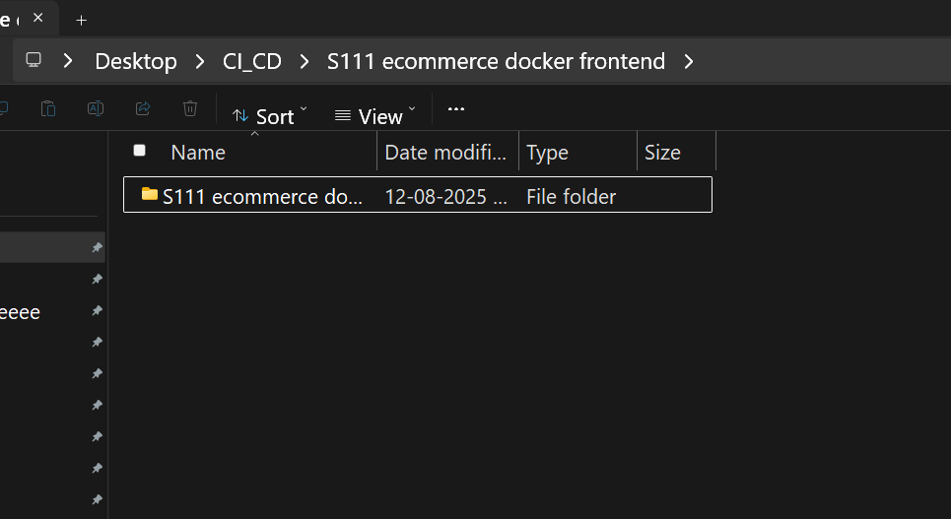

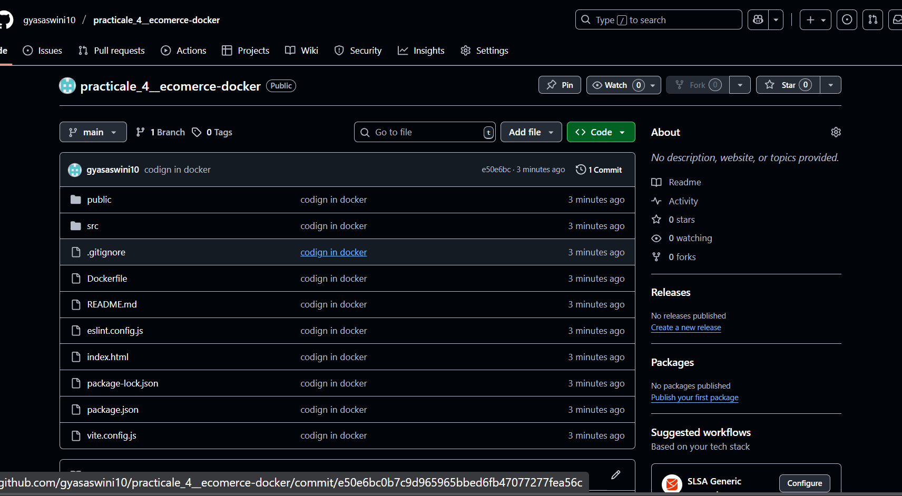

docker build -t ecommerce-app .

docker stop ecommerce-container || echo "No container to stop"

docker rm ecommerce-container || echo "No container to remove"

docker run -d -p 8082:8080 --name ecommerce-container ecommerce-app

